Button Debouncing

# Test Program for Button Bouncing – Counter

To test with the button bouncing and debouncing, I recommend a simple test program – **counter ­**

We will use Timer 0 of AVR Controller as **COUNTER (counting events/counting the number of presses)**

### Step 1 - Hardware setup

1. We will connect an external source to the Timer pin. Atmega328p has different pin layout, the Timer 0 function is shared with PD4 pin hence we need to configure it accordingly

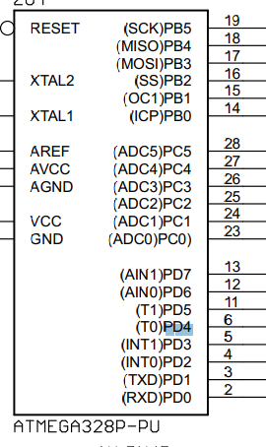

1. We will use this as our input pin for the Counter 0.
   1. Identify the pin
   2. Connect two jumpers to PD4 and GND out
   3. The PD4 will be connect to a button on our breadboard. To make it simple, use pull up resistor 1kOhms together with the button.

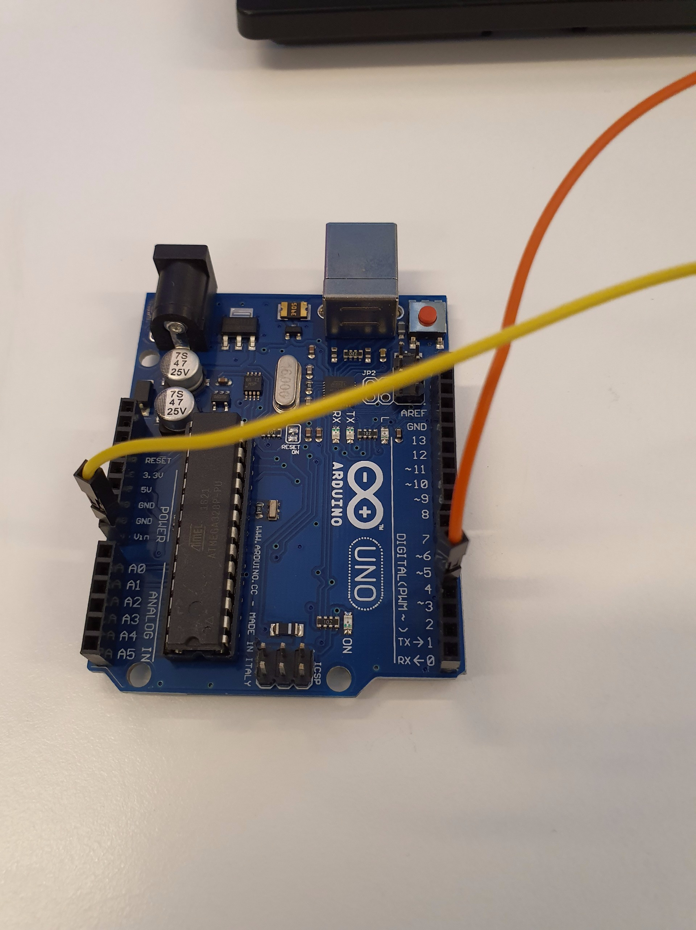

1. For the output of the counter, we will use Port C as the output put, so we will connect the PortC with LEDs. Again for simplicity, WE WILL USE ONLY FROM PC0 TO PC3. This means we will only observe the counter up to maximum 0b1111.

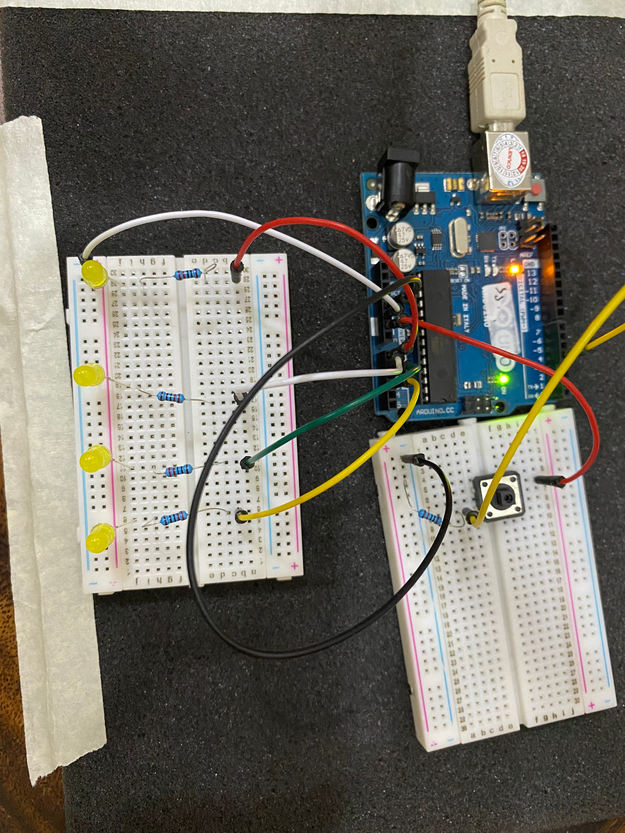

### Step 2 - Software

1. Create a new project
2. Type in the following code



1. Build and download the code.
2. Press the button and observe the LEDs
   1. Do you see the LEDs changing its statuses according to the sequence from a Binary counter?
   2. Do you see the values sometime jump up couple values? This shows the button bouncing has occurred

### Code Explanation

The key for the above code first and foremost is the setting of your Timer/Counter. To have it working as Counter, we need to connect the “trigger” to an external source.

* 1. Check the setting, you will see two options with CS02, CS01 and CS00

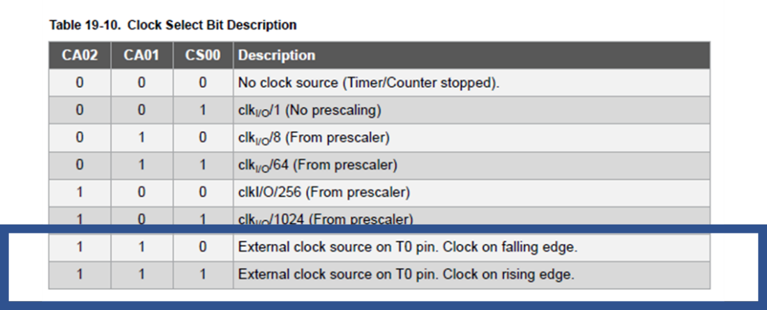

|  |
| --- |
| TCCR0B |= (1 << CS02) | (1 << CS01) | (1 << CS00); // Set up the external clock source on T0 |

* 1. As the Counter receives trigger clock, it will increase the counter values. To observe it we connect it to the PORTC

|  |
| --- |
| PORTC = TCNT0; //Read value from the counter value register to the PortC |

# Button Debounce Principles

## Preparation Step 1 - Definition of Button Bouncing

For this step, please Google and research around. You shall see the definitions and examples

## Preparation Step 2 - Profiling Button Bouncing

For this step, we don’t have the real devices to do so I will upload some reports from students in the previous semesters (ones got good answers). Please check these out.

In practice, during the profiling, the goal is to see how the debouncing happens and pay attention to the average time for a bounce to happen. For example, in the report of Student 1 on Canvas you can see **this information around 3ms**

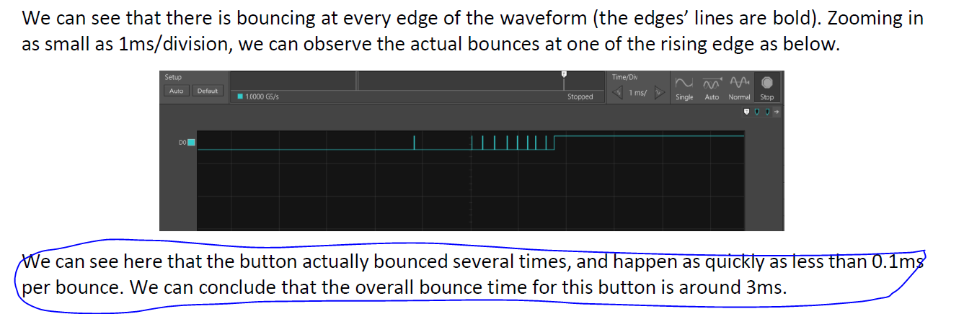

*This delay time is important since we can rely on it to debounce the button*

# Method 1 - Software Approach

The principle of this is to insert **a small delay** after the button is pressed. We assume that after this delay, the button will get stable and produce a valid input.

For example, we can use **_delay_ms** function to generate such a delay

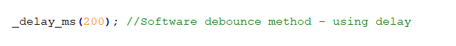

# Method 2 - Hardware Approach

For hardware approach, people tend to borrow the support from external chips/circuits to assist the debouncing.

One of the common solutions is to use filters to remove noises generated from the bouncing (i.e., low-frequency noise). In specific, we need **a low pass filter with a pair of R and C.** Their values are chosen to address the delay from profiling earlier. In addition to the filter, to use the output from the button. The output of the filter is then connected to a Logic gate called **a Schmitt Trigger inverter,** to smooth the analog signal to proper digital signals for MCU.

Below is a schematic for the circuit.



*Note – in case you don’t have an inverter, sometimes we can use the RC filter only and it can work too.*